CALLMEDIA CX NOW ORDER FORM
This Order Form is part of and shall be governed by, the CALLMEDIA CX NOW Agreement and its schedules (together known as this “Agreement”). A copy of the CALLMEDIA CX NOW Agreement and its schedules are available at the following: https://www.maintel.co.uk/callmedia-cx-now-terms-conditions/or a copy is available upon request.

Customer: | [INSERT CUSTOMER FULL ENTITY NAME ] a company registered in [INSERT CUSTOMER COUNTRY OF REGISTRATION] with company number [INSERT CUSTOMER COMPANY REG NUMBER] and having its registered office at [INSERT CUSTOMER FULL REG ADDRESS ]
This Order Reference |  | [INSERT OPPORTUNITY_QUOTE_NUMBER]

TRIAL TYPE and PERIOD
The Trial type shall be either a i) Provisional Service or ii) Proof of Concept as indicated below:

Trial Type | Tick one only | Trial Service Period (days)
Provisional Service
Proof of Concept
No Trial | Please tick here

The Provisional Service Period shall be as stated in the above table and shall commence from the date of signature of this Order (“Effective Date”).

Where a Provisional Service Period is identified (as above), and where the Customer does not issue a formal termination notice before the indicated Provisional Service Period identified on this Order expires; the Callmedia CX Now Service as identified in this Order, shall be implemented in full for the Initial Term. Such Initial Term shall commence on the Provisional Service Activation Date at the end of the Provisional Service Period.

Where a Trial is identified as a Proof of Concept (set out in the above table) and the Customer does not issue a new Order (in this form), prior to the indicated Proof of Concept expiration; the Callmedia CX Now Service as identified herein shall terminate in accordance with Clause [14] of this Agreement. For clarification purposes where a Proof of Concept is not extended, via placing a new Order, the Services shall not continue.

INTIAL TERM:
The Initial Term shall be _[INSERT TERM OF CONTRACT REQUIRED]__________months and shall commence from the Provisional Service Activation Date and/or the Service Activation Date, save where a Proof of Concept has been procured (as set out above).

Service Activation Date:
The Service Activation Date will be: [INSERT DATE WHEN CUSTOMER WANTS THE SERVICE TO BE LIVE]

Please note the Service Activation Date must be no less than one (1) week from the Effective Date. Furthermore, any timeline agreed within this Order shall be subject to the Customer providing Maintel accurate information within the required timeframe.

SERVICES
CALLMEDIA CX NOW (Table A)

Bundle Type | Additional 25 Real Time Information Connection Bundles | Integration Connectors | Application | Permanent PSTN Agent Connections | Real Time Information Connections
[SALES ENTER ] | [SALES ENTER qty number here] | [SALES ENTER qty number here] | [SALES ENTER] | [SALES ENTER qty number here] | [SALES ENTER qty number here – note this is in blocks of 25 so default to 25 then upwards]

ALL SERVICES
Installation, configuration, programming, training and project management to be supplied by Maintel (Table B)
Set Up Professional Services Pack to be supplied by Maintel (Table B1)
Service | Description
PS Pack allowance | [SALES ENTER DESCRIPTION HERE]

Service Options available (Table B2)
Platform Initiation | Start Platform | Digital Platform
Stand up of CM CX Now dedicated compute platform on AWS | ü | ü
Provision of public internet connectivity in AWS (for Agents) | ü | ü
Provision of SIP connectivity back to ICON carrier grade SBC | ü | ü
Provision of SIP trunks to Gamma – default 1:1.2 Agent ratio | ü | ü
Deploy Callmedia CX Now Software | ü | ü
Set up monitoring services | ü | ü
System test | ü | ü
Document build (for support and management purposes) | ü | ü
Platform Initiation | Optional Start Professional Service Bundle | Optional Digital Professional Service Bundle
Delivery Management Service including the below | ü | ü
Application Configuration workshop |  | ü
Configure inbound voice (Configured trunks and up to 25 voice channel queues) | ü | ü
Configure1 x Wallboard (virtual – customer supplies terminal) | ü | ü
Configure reporting in line with requirements identified in workshop | ü | ü
Configure recording | ü | ü
Configure email – Up to 10 queues |  | ü
Configure up to 10 Web Chat landing page to queues, chat topics configured. Customer’s own Web Dev to build chat sites |  | ü
Configure SMS no’s & up to 10 queues |  | ü
Configure Call Back? |  | ü
Configure outbound dialler |  | ü
Training - One course per topic (Supervisor, Admin/IT, Train the Trainer). Onsite is subject to expenses & travel agreement. Max 5 delegates per course. | ü | ü
User Acceptance Testing Support | ü | ü
Transition service | ü | ü
Go Live Number Porting | ü | ü
Go Live hand holding | ü | ü
 | + additional Custom Services e.g. extra training, configuration, integration quoted separately | + additional Custom Services e.g. extra training, configuration, integration quoted separately

Additional time and materials Professional Services to be supplied by Maintel (Table B3)
Qty | Description

CHARGES
Minimum Commitment (Table C)
Payment Frequency  (Monthly/Annually in advance) | Minimum Commitment (£) for the Initial Term
{{OPPORTUNITY_BILLING_FREQUENCY}} | {{TableStart:QueryData2}}{{IQUOTE_CX_NOW_MIN_COMMITMENT\# £#,###.00 }}{{TableEnd:QueryData2}}

Subscription Rate Card to apply for additional users (Table D)
Bundle Type | Monthly Charge (£)
Start | £35
Digital | £55
25 Real Time Information Connection Bundle | £100 for every block of 25 added
Permanent PSTN Agent Connections | £7.37 per connection

CALL CHARGES
Call Tariffs (Table E)
Call Charges
The full call charge tariff is available at HERE.
Peak Rate is Monday to Friday 08:00 to 18:00, Off Peak is all other times on Monday to Friday and weekend rate is all times on Saturday and Sunday. Charges are shown per minute but incurred on a per second basis.
Inclusive Call Bundle
Is described at the top of the call charge tariff as detailed above

Summary of Charges
IMPLEMENTATION CHARGES
Description | Charge (£)
Implementation Services (as stated in Tables A, B1, B2 and E)
One-off set up Charge for the professional services for the Service. The Professional Service Charges shall be invoiced upon signature of the Order Form.

OPERATIONAL CHARGES
Subscription Operational Services (as stated in Tables A, B2, C, D, E)
Subscriptions will be invoiced as per the payment frequency (Table D) and any use over the agreed amounts (and Overage Charge) shall be invoiced monthly in arrears.

This Order is subject to the terms of this Agreement between the Customer and Maintel as set out in the CALLMEDIA CX Now Agreement and its schedules.

By and on behalf of the Customer

Signature
Print Name

Title

Date

APPENDIX 5 – DIRECT DEBIT MANDATE

Settling your monthly Maintel Europe Ltd invoice by Direct Debit couldn't be easier.

• No more cheques to write

• No need to remember to post your payment in time

All you need to do is complete and return the Direct Debit Mandate below and we'll take care of the rest. If you have any questions about paying by Direct Debit, please contact your dedicated customer service team on the number shown on your invoice.

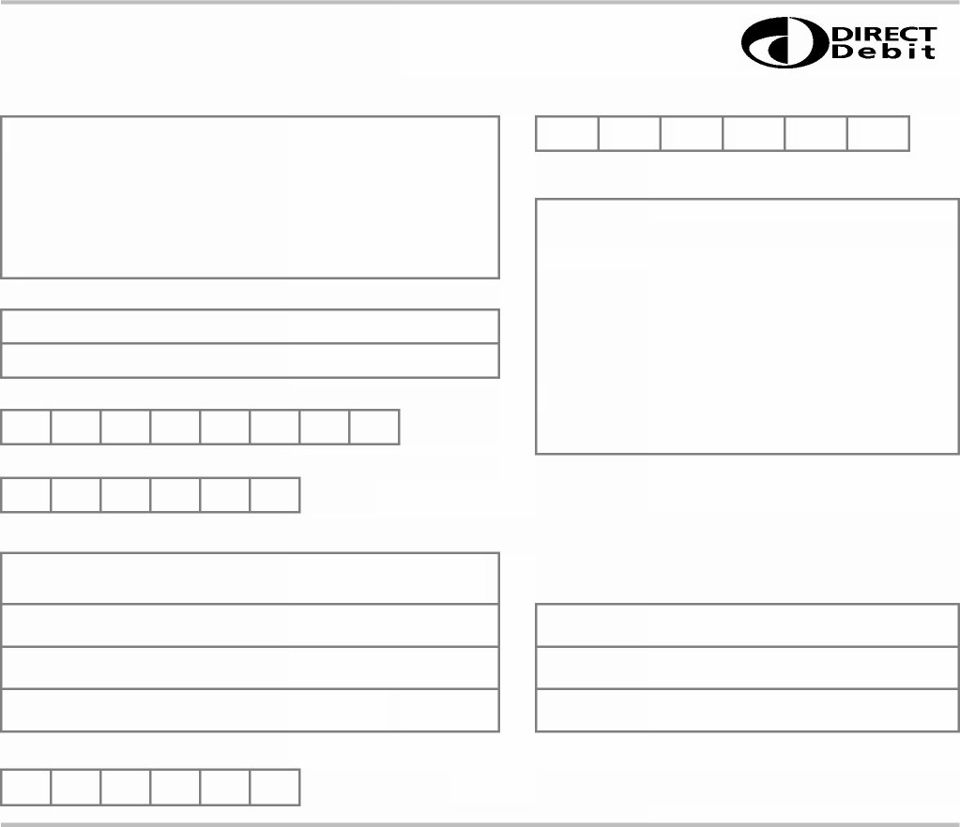
D I R E C T D E B I T M A N D A T E

Please fill in the whole form using a ball point pen and send it to: Originator's Identification Number
6 | 2 | 4 | 9 | 2 | 2

Maintel Europe Ltd
Finance Department
160 Blackfriars Road

London
SE1 8EZ

FOR MAINTEL EUROPE LTD OFFICIAL USE ONLY
This is not part of the instruction to your Bank/Building Society

Name(s) of account holder(s)

Bank/Building Society account number

Branch Sort Code
Instruction to your Bank or Building Society to pay by Direct Debit

Name and full postal address of your Bank/Building Society

To: The Manager Bank/Building Society

Address
Please pay Maintel Europe Limited direct debits from the account detailed in this Instruction subject to the safeguards assured by the Direct Debit Guarantee. I understand that this Instruction may remain with Maintel Europe Ltd and, if so, details will be passed electronically to my Bank/Building Society.

Signature(s)

Postcode Date

Reference Number - Your Maintel Europe Ltd account number

Banks and Building Societies may not accept Direct Debit Instructions from some types of account.

T H E D I R E C T D E B I T G U A R A N T E E

This guarantee should be detached and retained by the Payer

• This Guarantee is offered by all Banks or Building Societies that take part in the Direct Debit Scheme. The efficiency and security of the Scheme is monitored and protected by your own Bank or Building Society
• If the amounts to be paid or the payment dates change, Maintel Europe Limited will notify you 10 working days in advance of your account being debited or as otherwise agreed.
• If an error is made by Maintel Europe Limited or your Bank or Building Society, you are guaranteed a full and immediate refund from your branch of the amount paid.
• You can cancel a Direct Debit at any time by writing to your Bank or Building Society. Please also send a copy of your letter to us.

Maintel Europe Limited. Registered in England No: 2665837. VAT No: GB 744 3365 31

